**Question-1:- Use ps to search for the “systemd” process by name.**

**Ans :- “**systemd” is a daemon process which starts as soon as the computer starts and continue till the system is shutdown. It was a replacement of **init** daemon. So it always has a **PID 1**.

Command:- **ps -fC init🡪** ’ps’ is used to view running process in a system. ‘-C’ is used to search a process by its name or command. And init is the name of process.(init is replaced by system).

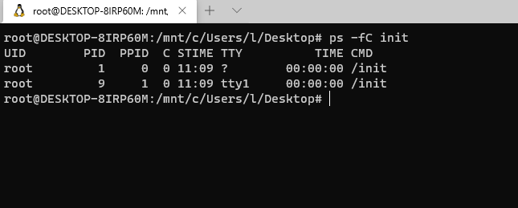

**Fig** shows ps to search a process by its name

**Question-2:- Find out your terminal name.Using your terminal name, use ps to find all processes associated With your terminal.**

**Ans:-**

Command:- **tty:-** is used to display terminal name

**ps –T:-** is used to display process running in current terminal

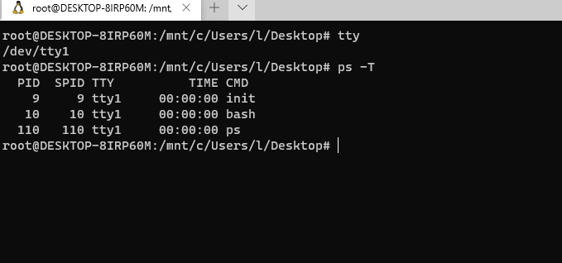

**Fig** shows current terminal name and all process running in current terminal

**Question-3:- Check and note the process id of your shell(from the output of the above command). Also, note the parent process id of your shell.**

Ans:-

Command:- **ps –p $$:-** Displays current shell PID.

**ps –F:-** Displays full format process associated with this pid.

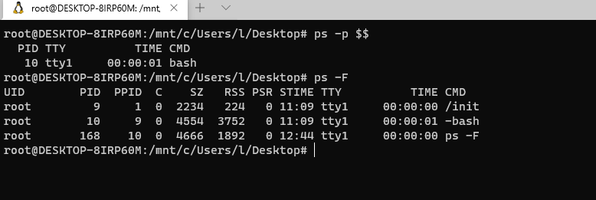

**Fig** shows pid and ppid of current terminal

**Question-4:- Start 3 instances of “sleep 123” as background processes.**

**Ans:-**

Commad:- **sleep 123 &:-**  create an instance of sleep 123 in the background

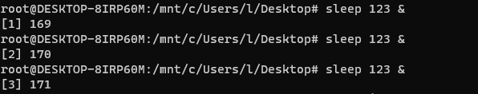

**Fig** shows creation of sleep 123 instances in the background.

**Question-5:- Check and note the process id’s of all sleep processes.**

**Ans:-**

Command:- **ps -e | grep sleep:-** shows all the process id’s of sleep instances.

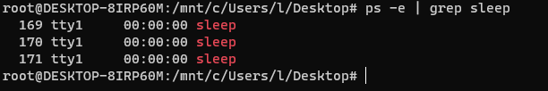

**Fig** shows PID of all sleep processes

Question-6:- Display only those three sleep processes in top. Then quit top.

**Ans:-**

Command: -**top -p pid,pid,pid**

